1. Write a Java Servlet via implementing Servlet Interface that displays “Hello Servlet!!!” message in the browser. Also write the directory structure and the Deployment Descriptors.

First.java

import java.io.\*;

import javax.servlet.\*;

public class First implements Servlet{

ServletConfig config=null;

public void init(ServletConfig config){

this.config=config;

System.out.println("servlet is initialized");

}

public void service(ServletRequest req,ServletResponse res)throws IOException,ServletException{

res.setContentType("text/html");

PrintWriter out=res.getWriter();

out.print("<html><body>");

out.print("<b>hello simple servlet</b>");

out.print("</body></html>");

}

public void destroy(){System.out.println("servlet is destroyed");}

public ServletConfig getServletConfig(){return config;}

public String getServletInfo(){return "copyright 2007-1010";}

}

Web.xml

<web-app>

<servlet>

<servlet-name>s1</servlet-name>

<servlet-class>First</servlet-class>

</servlet>

<servlet-mapping>

<servlet-name>s1</servlet-name>

<url-pattern>/hello</url-pattern>

</servlet-mapping>

</web-app>

O/P:-

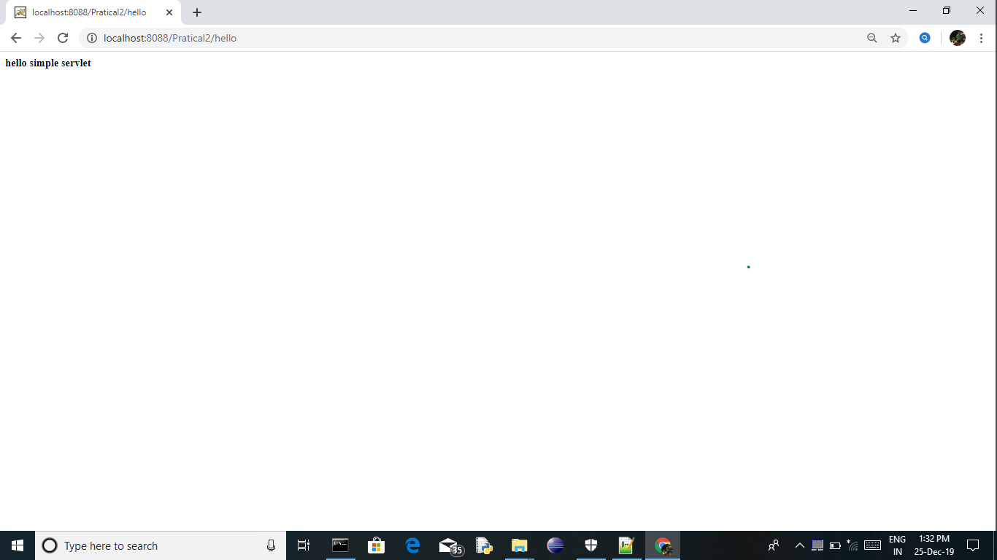

2) Write a Java Servlet Using Generic Servlet that displays Welcome

Message with Current timestamp and number of day in the year in the browser.

import java.io.\*;

import javax.servlet.\*;

import java.util.\*;

public class TimeStampExample extends GenericServlet{

public void service(ServletRequest req,ServletResponse res) throws IOException,ServletException{

res.setContentType("text/html");

PrintWriter out=res.getWriter();

Date today = new Date();

out.print("Today's DateTime is :" + today.toString());

}

}

Output:



3) Create an HTML page to provide Login facility to user. Create a servlet to check the username and password and if correct then display the appropriate user specific message along with their login time.

LoginAuthenticate.java

import java.io.\*;

import java.util.\*;

import javax.servlet.ServletException;

import javax.servlet.http.HttpServlet;

import javax.servlet.http.HttpServletRequest;

import javax.servlet.http.HttpServletResponse;

public class LoginAuthenticate extends HttpServlet {

public void doPost(HttpServletRequest request, HttpServletResponse response)

throws ServletException, IOException {

response.setContentType("text/html");

String finalusername = "admin";

String finalpassword = "admin";

final PrintWriter out = response.getWriter();

String username = request.getParameter("username");

String Password = request.getParameter("password");

Date today = new Date();

if(finalusername.equals(username) && finalpassword.equals(Password)){

out.println("<h1>Good Morning Mr . " + username + "<h1>");

out.println("<h1>Login Time Date : " + today.toString() + "</h1>");

}else{

out.println("<h1>Username or Password Wrong.</h1>");

}

}

}

Index.html

<html>

<head>

<title>Login Page</title>

</head>

<body>

<form action="UserAuthenticate" method="POST">

<h1>Login</h1>

Username : <input type="text" name="username"><br><br>

Password : <input type="password" name="password"><br><br>

<input type="submit" name="submit" value="Log In">

</form>

</body>

</html>

O/P:-



4) Design a Personal Detail Collection form which requests user to enter their details like name, address, DoB, Gender, Hobbies etc. Use different.HTML controls in your design. Write a Java Servlet program which receives parameter using GET method from HTML and displays them appropriately.

StudentInfo.java

import java.io.\*;

import javax.servlet.ServletException;

import javax.servlet.http.HttpServlet;

import javax.servlet.http.HttpServletRequest;

import javax.servlet.http.HttpServletResponse;

public class StudentInfo extends HttpServlet{

public void doGet(HttpServletRequest req,HttpServletResponse res)throws IOException,ServletException{

String name = req.getParameter("name");

String add = req.getParameter("add");

String bdate = req.getParameter("bdate");

String gender = req.getParameter("gender");

String hobbie = req.getParameter("hobbie");

PrintWriter out = res.getWriter();

out.print("<html>");

out.print("<head>");

out.print("<body><pre>");

out.print("<h1> REGISTRATION DETAILS </h1>");

out.print("<table border='1'");

out.print("<tr>");

out.print("<td>");

out.print("Name");

out.print("</td>");

out.print("<td>");

out.print(name);

out.print("</td>");

out.print("</tr>");

out.print("<tr>");

out.print("<td>");

out.print("Address");

out.print("</td>");

out.print("<td>");

out.print(add);

out.print("</td>");

out.print("</tr>");

out.print("<tr>");

out.print("<td>");

out.print("Birth Date");

out.print("</td>");

out.print("<td>");

out.print(bdate);

out.print("</td>");

out.print("</tr>");

out.print("<tr>");

out.print("<td>");

out.print("Gender");

out.print("</td>");

out.print("<td>");

out.print(gender);

out.print("</td>");

out.print("</tr>");

out.print("<tr>");

out.print("<td>");

out.print("Hobbies");

out.print("</td>");

out.print("<td>");

out.print(hobbie);

out.print("</td>");

out.print("</tr>");

out.print("</table>");

out.print("</pre></body>");

out.print("</head>");

out.print("</html>");

}

}

StudentForm.html

<html>

<head>

<title>Student Form</title>

</head>

<pre>

<form action="Showdata" method="GET">

<h1>Registration Form</h1>

Name : <input type="text" name="name"><br><br>

Address : <input type="text" name="add"><br><br>

BirthDate : <input type="date" name="bdate"><br><br>

Gender : <input type="text" name="gen"><br><br>

Hobbies : <input type="text" name="hobbie"><br><br>

<input type="submit" name="submit" value="Register">

</form>

</pre>

</html>

o/p:-





5) Design a SurveyCollection form which requests user to enter their views on any product like thier name, email address, Mobile, DoB, Gender, Product name they purchased, Product Cost, satisfaction scale, any other comments etc. Use different. HTML controls in your design. Write a Java Servlet program which receives parameter using POST method from HTML and displays them appropriately.

import java.io.\*;

import javax.servlet.ServletException;

import javax.servlet.http.HttpServlet;

import javax.servlet.http.HttpServletRequest;

import javax.servlet.http.HttpServletResponse;

public class ProductSurvey extends HttpServlet{

public void doPost(HttpServletRequest req,HttpServletResponse res)throws IOException,ServletException{

String name = req.getParameter("name");

String email = req.getParameter("email");

String bdate = req.getParameter("bdate");

String gender = req.getParameter("gender");

String mobile = req.getParameter("mo");

String pname = req.getParameter("pname");

String pprice = req.getParameter("pprice");

String pscale = req.getParameter("pscale");

PrintWriter out = res.getWriter();

out.print("<html>");

out.print("<head>");

out.print("<body><pre>");

out.print("<h1> PRODUCT SURVEY DETAILS </h1>");

out.print("<table border='1'");

out.print("<tr>");

out.print("<td>");

out.print("Name");

out.print("</td>");

out.print("<td>");

out.print(name);

out.print("</td>");

out.print("</tr>");

out.print("<tr>");

out.print("<td>");

out.print("Email");

out.print("</td>");

out.print("<td>");

out.print(email);

out.print("</td>");

out.print("</tr>");

out.print("<tr>");

out.print("<td>");

out.print("Birth Date");

out.print("</td>");

out.print("<td>");

out.print(bdate);

out.print("</td>");

out.print("</tr>");

out.print("<tr>");

out.print("<td>");

out.print("Gender");

out.print("</td>");

out.print("<td>");

out.print(gender);

out.print("</td>");

out.print("</tr>");

out.print("<tr>");

out.print("<td>");

out.print("Mobile Number ");

out.print("</td>");

out.print("<td>");

out.print(mobile);

out.print("</td>");

out.print("</tr>");

out.print("<tr>");

out.print("<td>");

out.print("Product Name ");

out.print("</td>");

out.print("<td>");

out.print(pname);

out.print("</td>");

out.print("</tr>");

out.print("<tr>");

out.print("<td>");

out.print("Product Price ");

out.print("</td>");

out.print("<td>");

out.print(pprice);

out.print("</td>");

out.print("</tr>");

out.print("<tr>");

out.print("<td>");

out.print("Product Scale");

out.print("</td>");

out.print("<td>");

out.print(pscale);

out.print("</td>");

out.print("</tr>");

out.print("</table>");

out.print("</pre></body>");

out.print("</head>");

out.print("</html>");

}

}

ProductSurvey.html

<html>

<head>

<title>Product Survey Page</title>

</head>

<body>

<form action="Report" method="POST">

<pre>

<hr><h1>Product Survey Form</h1><hr>

Name : <input type="text" name="name"><br>

Email : <input type="text" name="email"><br>

BirthDate : <input type="date" name="bdate"><br>

Mobile no : <input type="text" name="mo"><br>

Gender : <input type="text" name="gen"><br>

Product Name : <input type="text" name="pname"><br>

Product Scale : <input type="text" name="pscale"><br>

Product Price : <input type="number" name="pprice"><br>

<input type="submit" name="submit" value="Submit">

</pre>

</form>

</body>

</html>

O/P:-





6) Create a calculator Servlet which can perform selected single operation on any given two operands.

Calc.java

import java.io.\*;

import javax.servlet.ServletException;

import javax.servlet.http.HttpServlet;

import javax.servlet.http.HttpServletRequest;

import javax.servlet.http.HttpServletResponse;

public class Calc extends HttpServlet{

public void doPost(HttpServletRequest req, HttpServletResponse res) throws IOException, ServletException {

PrintWriter out = res.getWriter();

String add = "ADDITION";

String sub = "SUBTRACTION";

String mul ="MULTIPLICATION";

String div = "DIVISION";

int n1 = Integer.parseInt(req.getParameter("n1"));

int n2 = Integer.parseInt(req.getParameter("n2"));

if(add.equals(req.getParameter("add"))){

int result = n1 + n2;

out.print("ADDITION : " + result);

}

if(sub.equals(req.getParameter("sub"))){

int result = n1 - n2;

out.print("SUBTRACTION : " + result);

}

if(div.equals(req.getParameter("div"))){

if(n2 < 0){

out.print("Enter Valid Number ");

}

int result = n1 / n2;

out.print("DIVISON : " + result);

}

if(mul.equals(req.getParameter("mul"))){

int result = n1 \* n2;

out.print("MULTIPLICATION : " + result);

}

}

}

Calc.html

<html>

<head>

<title>Calculater</title>

<body>

<form action="result" method="POST">

<pre>

Number 1 : <input type="text" name="n1"><br>

Number 2 : <input type="text" name="n2"><br>

<input type="submit" name="add" value="ADDITION"> <input type="submit" name="sub" value="SUBTRACTION"><br>

<input type="submit" name="mul" value="MULTIPLICATION"> <input type="submit" name="div" value="DIVISION"><br>

</pre>

</form>

</body>

</head>

</html>

O/P:-





